PRIORITY’S MONTHLY DRAWING
10 WINNERS

January 9th – 18th, 2012

Three Prizes!!!

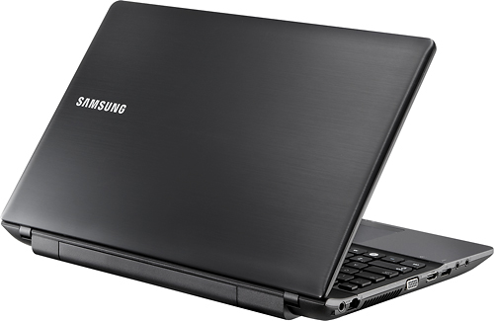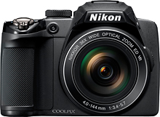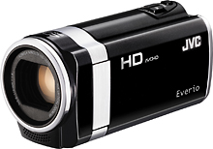

Samsung 15.6” Laptop Nikon Coolpix P500 JVC HD Camcorder

$500.00 value $400.00 value $300.00 value

Get your name entered in the drawing for every $3000 entered for shipment from
Monday January 9th through Wednesday January 18th, 2012.
$3,000=1 Entry, $9,000=3 Entries, $30,000=10 Entries etc.
Customers will be asked to complete a form for entry.
Promotion valid for Electrical, Utility, and Mining distributors only.
Drawing to be held on the 19th.

Contact your Sales Agency or P.W.C. Inside Sales Person for more details

Little Rock Office: 1-800-945-5542 Baton Rouge Office: 1-888-754-5707

Houston Office: 1-888-388-6280 Las Vegas Office: 1-702-696-0001

Chicago Office: 1-630-894-4900 Philadelphia Office: 1-215-874-4045

Mississauga, ON Office: 1-877-611-5122

